

1

**Undergraduate Thesis (Design)**

**本科毕业论文(设计)**

**Company website construction**

|  |  |
| --- | --- |
| **Level 2 College** | **Pharmaceutical College 药科学院** |
| **Major** | **Computer Science 计算机** |
| **Class** | **16级（留学生全英班）** |
| **Student Name** | **KAMWENUBUSA URBAIN** |
| **Student No.** | **1616501111** |
| **Supervisor** | **PROFESSOR WEI TAO** |

2020 年 5 月

**诚 信 声 明**

我声明，所呈交的毕业论文（设计）是本人在老师指导下进行的研究工作

及取得的研究成果。据我查证，除了文中特别加以标注和致谢的地方外，论文

（设计）中不包含其他人已经发表或撰写过的研究成果，也不包含为获得其他

教育机构的学位或证书而使用过的材料。我承诺，论文（设计）中的所有内容

均真实、可信。

毕业论文（设计）作者（签名）：

年 月 日

**Abstract**

**The goal of this project is to see people become more connected and see Africans business, jobs or industries be more connected with their clients. Our role is to equip local people in Africa to fulfill their daily lives and be able to reach more people through internet.**

**Our world has never been more connected as now and technology has never more advanced. We believe that people can be more readily available to people all over the world through websites.**

**The average person in the world spends 12 -32 hours per month on the Internet imagine if you could reach them for just a few minutes to share your ideas or news. It’s more than a possibility. Your business can begin to use the Internet as a tool to reach thousands of people. That’s what we’re all about and that’s why we do it!**

**For this reason, we decided to utilize a completely different development pattern that focuses on highly focused communication and transparent design patterns.**

**To help our fellow Africans to use the means of technology for their benefit and be able to reach the world with their creations.**

**Acknowledgements**

Firstly, I would like to thank the Almighty God.

Secondly, to my father **KAMWENUBUSA** **EMMANUEL** and my mother **ZANINKA ALICE**.

My brothers and sisters also my family members.

Special thanks to my family friend **NDIRABIKA PIERRE CLAVER and** his family.

To all my friends and colleagues, class mates, teachers and everyone who helped me through this journey.

I dedicate this study to them

**URBAIN KAMWENUBUSA**

**Thanks:**

Our sincerely thanks to Professor **TAO WEIYE**, the director of this brief.

He is availability, patience; advices and recommendation have been helpful to us in the culmination of this work.

We deeply thank the board members for their valuable time in reading and participating in the evaluation of this work.

To our dear Parents who have paid the schools fees from primary school to university.

We then say thanks in a distinguished way to all the people of Guangdong Pharmaceutical University for their help and collaboration during the period of our studies.

Also, to teachers who have participated in our training from primary school to university to all those who have contributed morally and material to the realization of this work.

We say THANK YOU.

**List of teachers (2016-2020)**

Dean: Professor Mrs. HE

Vice Dean: Professor Mr. Leo

|  |  |
| --- | --- |
| NAME | COURSE |
| 1. MR. WEIYE TAO | Networking Engineering |
| 1. Mr. XU WENHUA | Java programming |
| 1. Mr. WANG NING | Programming design |
| 1. Mrs. DORIS D. ZHONG | Photoshop |
| 1. Mr. WANG SHENG | Software Engineering |
| 1. Mr. LIANG HUOMING | Website Design Practice and enterprise resource planning |
| 1. Mr. ZHANG DAN | Graphic Animation |
| 1. Mr. XU QIANG | Computer fundamental |
| 1. Mr. CAI YONGMING | Database principle |

Table of Contents

Abstract ii

Acknowledgements iii

Thanks iv

List of Teachers v

Table of Contents vi

1 Introduction 8

1.1 What is a website? 8

1.2 Why a company need a website? 10

1.3 What are the things we need to create a website 15

1.4 About this project 17

2 HTML and CSS 19

2.1 What is HTML? 19

2.2 What is CSS? 20

2.3 Why use HMTL and CSS? What is the differnce between them? 21

3 Understanding HTML and CSSS basics codes? 23

3.1 HTML basics 23

3.2 CSS basics 28

3.3 HTML and CSS editors 32

4 Conclusion 39

**1 INTRODUCTION**

* 1. **What is a website ?**

**Definition**

**A website** is a collection of web pages and related content that is identified by a common domain name and published on at least one web server. Notable examples are wikipedia.org, google.com, and amazon.com.

All publicly accessible websites collectively constitute the World Wide Web. There are also private websites that can only be accessed on a private network, such as a company's internal website for its employees.

Websites are typically dedicated to a particular topic or purpose, such as news, education, commerce, entertainment, or social networking. Hyperlinking between web pages guides the navigation of the site, which often starts with a home page.

Users can access websites on a range of devices, including desktops, laptops, tablets, and smartphones. The software application used on these devices is called a web browser.

Websites can be used in various fashions: a personal website, a corporate website for a company, a government website, an organization website, etc.

Websites can be the work of an individual, a business or other organization, and are typically dedicated to a particular topic or purpose. Any website can contain a hyperlink to any other website, so the distinction between individual sites, as perceived by the user, can be blurred.

Some websites require user registration or subscription to access content. Examples of subscription websites include many business sites, news websites, academic journal websites, gaming websites, file-sharing websites, message boards, web-based email, social networking websites, websites providing real-time stock market data, as well as sites providing various other services.

* 1. **Why a company need a website?**

**A website** is a great way to provide value added service to your customers and clients, and is a great way to keep them coming back to you when they **need** your products or services. No matter what products you sell, you can share tips to your customers on how to use or care for the products they've purchased from you.

**Here are my 9 reasons why your business or company need a professional website?**

#### **YOUR BUSINESS WILL GAIN CREDIBILITY**

More and more people are searching online for things they want, for solutions to their problems, to compare prices, or just to get some information about a store, restaurant or business before they purchase from them. If you don’t have a website, potential customers will go to your competitors who do, especially if you are a home-based business without a bricks-and-mortar address.  
Having a website will not only provide the information they are looking for, but it will give your business credibility. It says, I am here, I mean business, and I am in it for the long haul.

#### **IT SAVES YOU MONEY IN THE LONG TERM**

A business owner, especially one that is just starting out, you’re probably thinking you can’t afford a professional website. But you really can’t afford NOT to. Although the cost of designing a website varies depending on your needs and your skill level, our company is here to help design, a professional website is worth the initial investment, which enables you to add and change your own content regularly, saving you money in updates.

#### **CUSTOMERS CAN BE KEPT INFORMED**

A website is an effective way of introducing your customers to new services, letting them know about new products, announcing upcoming events and special promotions. You can also provide added value by posting tips, resources and other information through a blog on your website. Unlike print ads, newspaper articles and flyers, which quickly become outdated, your website can provide current information and news. And if you discover a mistake after you publish a page or post, it is a quick fix.

#### **A WEBSITE IS ALWAYS ACCESSIBLE**

Unlike you bricks-and-mortar location, which is only open a few hours a day, a website is open 24 hours a day, 365 days a year. You can provide both regular and prospective customers the convenience of reviewing your products and services when your store or office is closed.

#### **A WEBSITE ENABLES YOU TO TARGET A WIDER AUDIENCE**

Websites are accessible from anywhere in the world provided there is an internet connection. Since more and more people have access to the internet, even in remote locations, you can target a much wider audience if your business has a website.

#### **IT PROVIDES A MEDIUM TO SHOWCASE YOUR WORK**

No matter what type of business you’re in, a website is a great place to showcase your work or demonstrate your skills. By including a portfolio, image gallery or videos, as well as testimonials about your work, you can demonstrate what makes your company or you unique.

#### **A WEBSITE SAVES YOU TIME**

Time is an important commodity in our ever increasing fast paced world even if you don’t attach a monetary value to it. Most people these days don’t have enough time for leisure, pleasure, family or healthy activities. Having a professionally designed website saves you time both in the short and long term.  
By providing information to your customers online, you can save a vast amount of valuable time that you would otherwise spend communicating to your prospects.

1. A WEBSITE CAN IMPROVE CUSTOMER SERVICE

A website is a great way to provide value added service to your customers and clients, and is a great way to keep them coming back to your when they need your products or services.  
No matter what products you sell, you can share tips to your customers on how to use or care for the products they’ve purchased from you.

1. YOU OWN AND CONTROL YOUR WEBSITE

Social media is a great way to bring traffic to your website and it’s a great way to share content *from* your website. However, relying solely on social media to attract customers or clients is not only preventing several prospects from doing business with you, but you do not own your your stuff and you cannot control what happens with it. The stuff you’ve uploaded to your favourite social media channel could disappear at any moment without prior warning when they pull the plug for what ever reason and you could lose it all forever.

**1.3 What are the things we need to**

**Create a website?**

**Things You Need To Start a professional Website**

**#1** Domain Name

A domain name is often the first thing you need when starting a website. It is your digital address that people will use to get connected to your website. Example www.ubuntuwebdesign.com

**#2** Business Email Address

 if you *need to build a website* that can help you attract new customers and grow your business, get a business email address with your website domain name.

**#3** Website Building Software

A website builder software is what you use to build your website.

Some of the more popular web builders that you might have heard of are **WordPress, Wix, Squarespace**and**Weebly.**

Or you can use HTML and CSS languages.

**#4** Website Hosting

A host is the storage unit where your website content lives online.

Whenever someone enters your domain name in a web browser, the browser will fetch your website content from your website host. Example Bluehost.

**#5** Website Template Design

A website template is a pre-made website design that allows you to have a professional-looking website without the need of hiring a website designer.

It gives you a quick, easy and economical way to create your website design.

**#6** Logo Design

Using a Logo is a great way to help create a brand for your business and website. Examples of some logo generator Squarespace logo generator (free) and Tailor Brands.

**#7**  High-Quality Images for Website

High quality images tell a story of your services and help create trust between your business and your clients.

* 1. **About this Project ?**

The goal of this project is to build a creative, functional website for people or business in need of it.

For this reason we decided to utilize a completely different development pattern that focuses on highly focused communication and transparent design patterns.

**Why We Do it**

Our heart and desire is to see more people and businesses become more connected. Our target is to equip local African people to fulfill their daily lives.

As we all know, our world has never been more connected as now and technology has never been more advanced. We believe that people can be more readily available to people all over the world through websites.

The average person spends 12 -32 hours per month on the Internet imagine if you could reach them for just a few minutes to share your ideas or news it will be a great opportunity for your businesses to grow an that’s why we are here to help you. It’s more than a possibility.

Your business can begin to use the Internet as a tool to reach thousands of people. That’s what we’re all about and that’s why we do it!

### **What We Do?**

When we take on a project not only do we work to craft the application according to the client’s specifications, we give daily updates to ensure that the project is aligning properly with the client’s goals. The end result is the right product, delivered on time, and on budge.ls.e r

1. **HTML and CSS**

**2 .1 What is HTML?**

**Hypertext Markup Language** (**HTML**) is the standard markup language for documents designed to be displayed in a web browser. It can be assisted by technologies such as Cascading Style Sheets (CSS) and scripting languages such as JavaScript.

Web browsers receive HTML documents from a web server or from local storage and render the documents into multimedia web pages. HTML describes the structure of a web page semantically and originally included cues for the appearance of the document.

HTML elements are the building blocks of HTML pages. With HTML constructs, images and other objects such as interactive forms may be embedded into the rendered page. HTML provides a means to create structured documents by denoting structural semantics for text such as headings, paragraphs, lists, links, quotes and other items.

**2 .2 What is CSS?**

**Cascading Style Sheets** (**CSS**) is a style sheet language used for describing the presentation of a document written in a markup language like HTML. CSS is a cornerstone technology of the World Wide Web, alongside HTML and JavaScript.

CSS is designed to enable the separation of presentation and content, including layout, colors, and fonts. This separation can improve content accessibility, provide more flexibility and control in the specification of presentation characteristics, enable multiple web pages to share formatting by specifying the relevant CSS in a separate .css file, and reduce complexity and repetition in the structural content.

Separation of formatting and content also makes it feasible to present the same markup page in different styles for different rendering methods, such as on-screen, in print, by voice (via speech-based browser or screen reader), and on Braille-based tactile devices.

CSS also has rules for alternate formatting if the content is accessed on a mobile device.

The name *cascading* comes from the specified priority scheme to determine which style rule applies if more than one rule matches a particular element. This cascading priority scheme is predictable.

**2.3 Why use HTML and CSS? What is the difference between them?**

HTML and CSS are two different types of *markup* (code), which have their own unique *syntax* (the arrangement in which code is written). There’s an important distinction between the two. You can think of the HTML as the structure for the page, while the CSS gives the HTML it’s styling.

**HTML** = **structure**  
**CSS** = **style**

As you browse through the alternate designs for the site, bear in mind that every single design uses exactly the same HTML! The only thing that changes from design to design is the CSS file. This is a great example of what can be accomplished using just CSS to change the look of a web page.

**Linking your HTML and CSS files**

We have first to create a new file called “style.css” and save it in the same folder as your file called “index.html”.

Before we even write the CSS, we actually have to go back to our HTML and write a new line to link the html file and the css file together. So, open up the index.html file from the previous tutorial and add the highlighted line of code below (line 5) to the <head> section of your document. The result should look like this:

<!DOCTYPE html>

<html>

<head>

<title>This is my page title.</title>

**<link href="style.css" rel="stylesheet" type="text/css" />**

</head>

<body>

<h1>This is a heading 1 element</h1>

<p>Hello world, this is a simple paragraph.</p>

</body>

</html>

**3 Understanding HTML and CSS basics code?**

**3 . 1 HTML basics**

**Headings**

Headings may be one of the easiest codes to learn and considering how crucial they are to your SEO, it's a good thing. There are six different types:

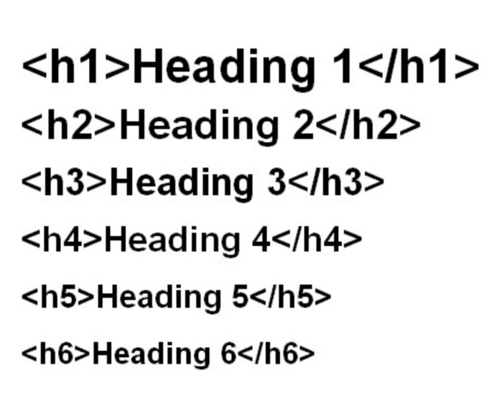

**Links**

Links are found in nearly all web pages. Links allow users to click their way from page to page. Example:

**HTML Links – The target Attribute**

The target attribute specifies where to open the linked document.

The target attribute can have one of the following values:

* _blank – Opens the linked document in a new window or tab
* _self – Opens the linked document in the same window/tab as it was clicked (this is default)
* _parent – Opens the linked document in the parent frame
* _top – Opens the linked document in the full body of the window
* framename – Opens the linked document in a named frame

### **Images**

Images helps to improve the design and the appearance of a web page.

Example:



Result:

## **The alt Attribute**

## The alt attribute provides an alternate text for an image, if the user for some reason cannot view it (because of slow connection, an error in the src attribute, or if the user uses a screen reader).

**Text formatting elements.**

Formatting elements were designed to display special types of text:

* <b> - Bold text
* <strong> - Important text
* <i> - Italic text
* <em> - Emphasized text
* <mark> - Marked text
* <small> - Small text
* <del> - Deleted text
* <ins> - Inserted text
* <sub> - Subscript text
* <sup> - Superscript text

eg: <p>My favorite color is <del>blue</del> red.</p>

**Paragraph**

A paragraph always starts on a new line, and browsers automatically add some white space (a margin) before and after a paragraph.

Example:

<p>This is a paragraph.</p>  
<p>This is another paragraph.</p>

**Video and Audio**

The HTML video and audio element specifies a standard way to embed a video in a web page.

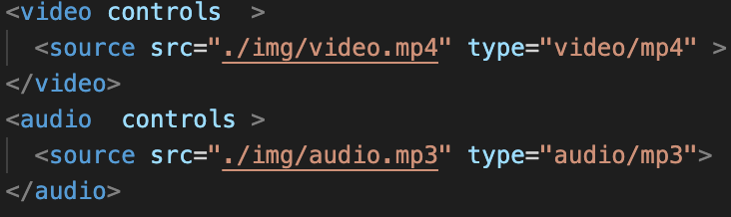  
Result:

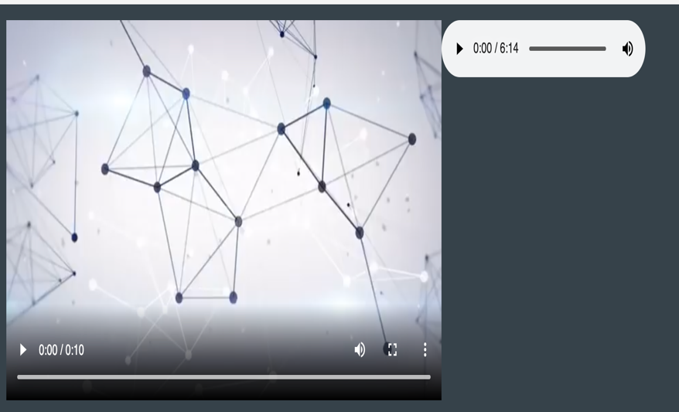

**3.2 CSS basics**

**Colors**

Colors are specified using predefined color names, or RGB, HEX, HSL, RGBA, HSLA values and can also be specified by using a color name.

Example:

CSS color code

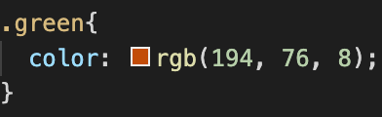

Result

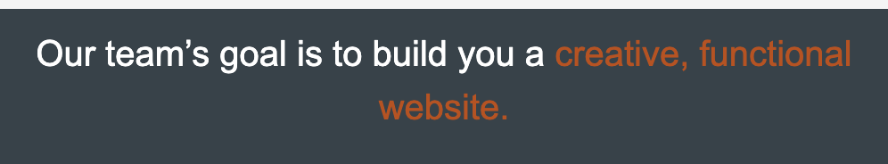

**Height and width**

The height and width properties are used to set the height and width of an element.

The height and width properties do not include padding, borders, or margins. It sets the height/width of the area inside the padding, border, and margin of the element.

## **height and width Values**

The height and width properties may have the following values:

* auto - This is default. The browser calculates the height and width
* length - Defines the height/width in px, cm etc.
* % - Defines the height/width in percent of the containing block
* initial - Sets the height/width to its default value
* inherit - The height/width will be inherited from its parent value

Example:

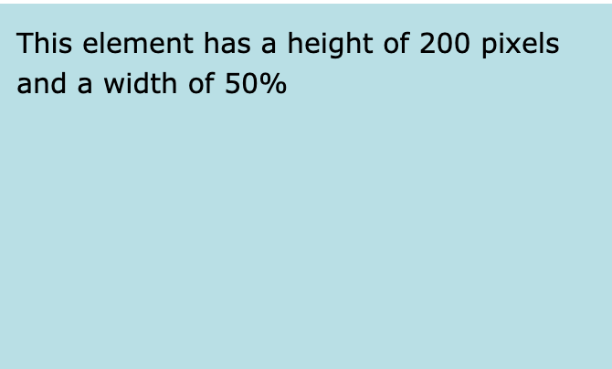

**Box model**

All HTML elements can be considered as boxes. In CSS, the term "box model" is used when talking about design and layout.

The CSS box model is essentially a box that wraps around every HTML element. It consists of: margins, borders, padding, and the actual content.

Example:

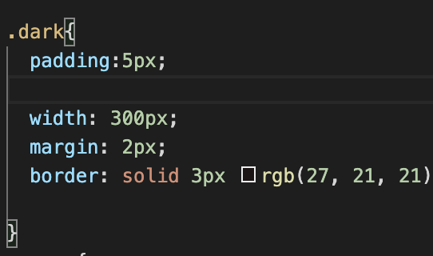

Result: 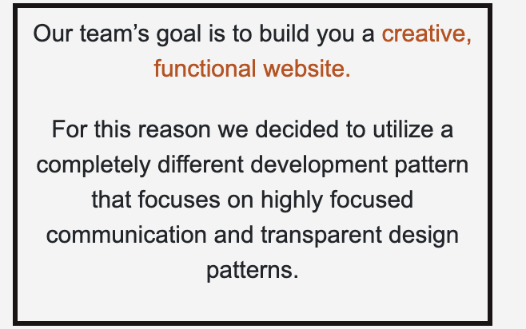

**3. 3 HTML and CSS editors.**

A text editor is all you need to learn and create HTML and create.

Examples of editors TextEdit for mac users, notepad for pc users, sublime text, vs code etc...

In this project I used vs code which is visual studio code:

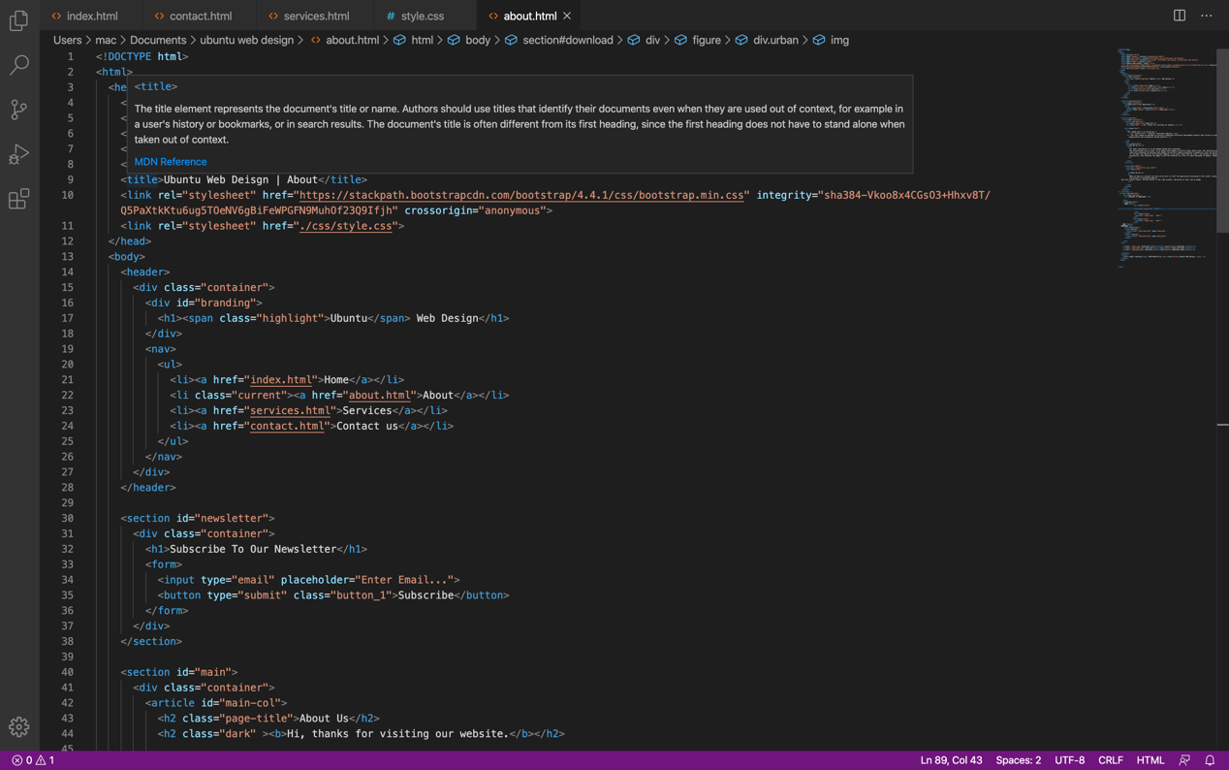

**Steps to create my web page with vs code.**

## **Step 1: Create a folder and give it a name.**



Drag the images for your website it the folder.

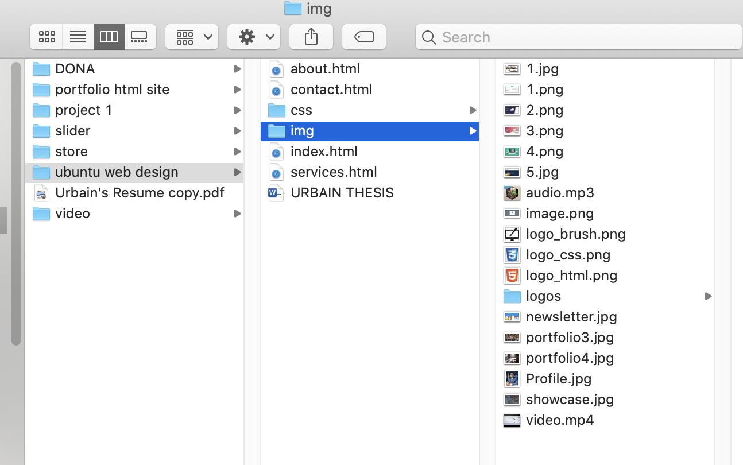

**Step 2:Open VS code**

Open **Finder > Applications > Vs code**

**Click on file > new file to create the HTML and CSS files.**

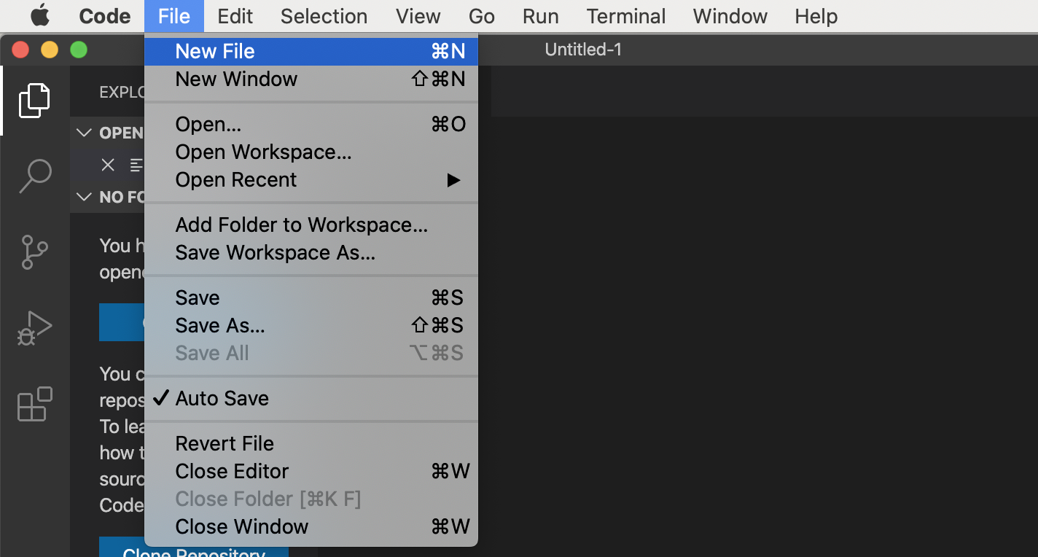

**Step 3: Save the HTML and CSS pages.**

Click on **file >save as**

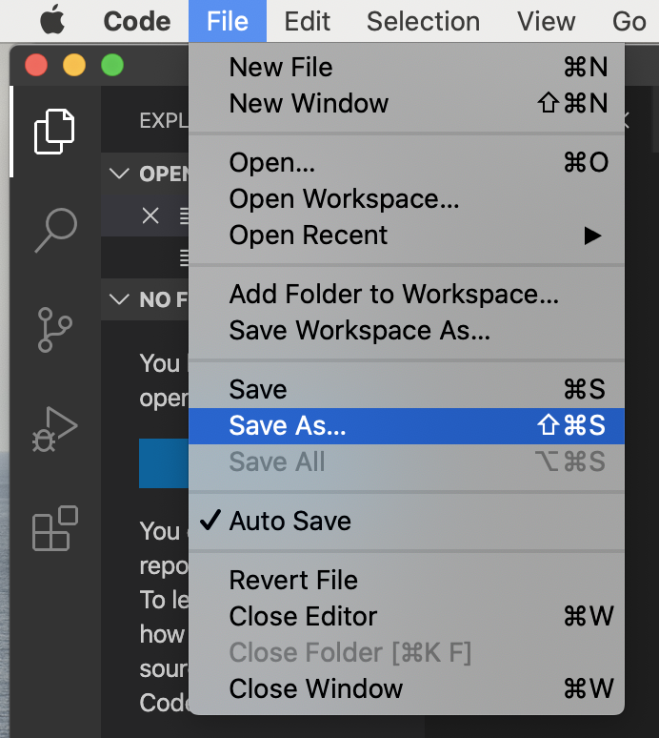

For HTML you save with .html extension

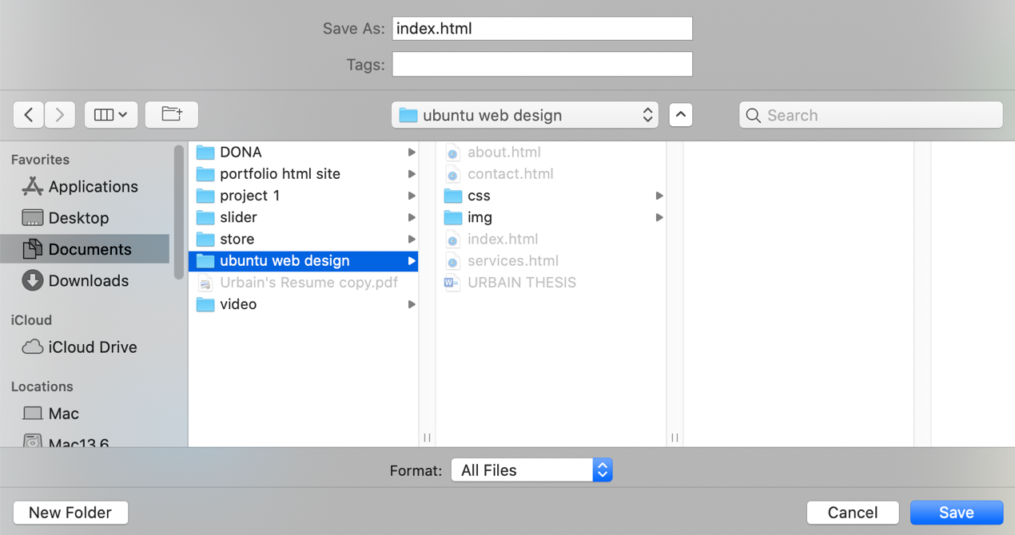

For CSS you save with .css extension

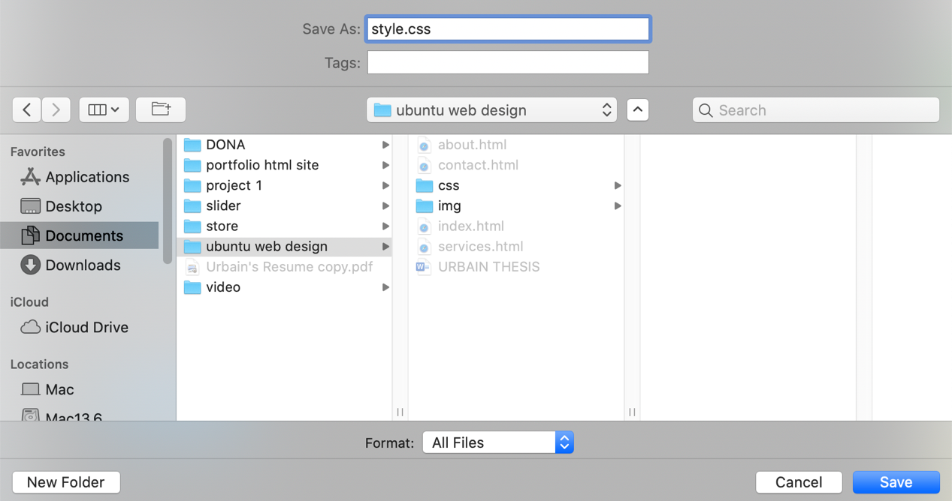

**Step 4: Write Some HTML and CSS**

HTML. CSS

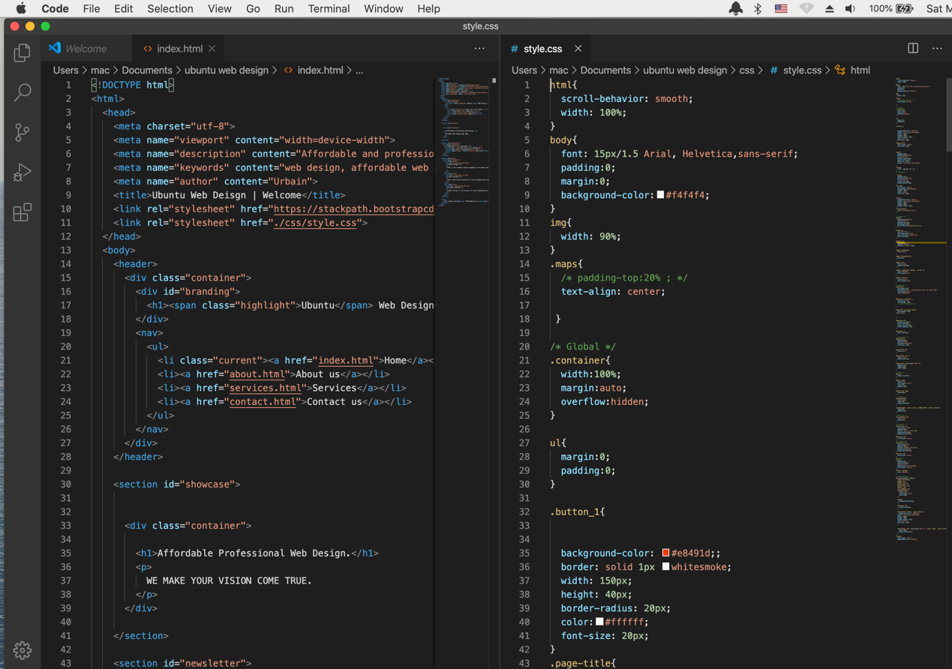

**Step 5: Write Some HTML and CSS**

Open the saved HTML file in google chrome or any other browser (double click on the file, or right-click - and choose "Open with").The result will look much like this:

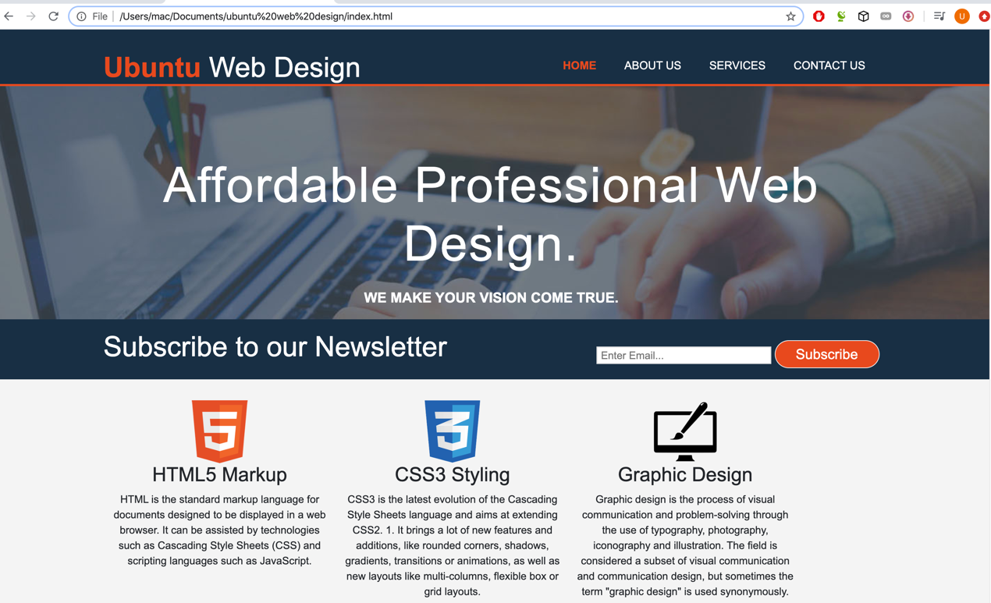

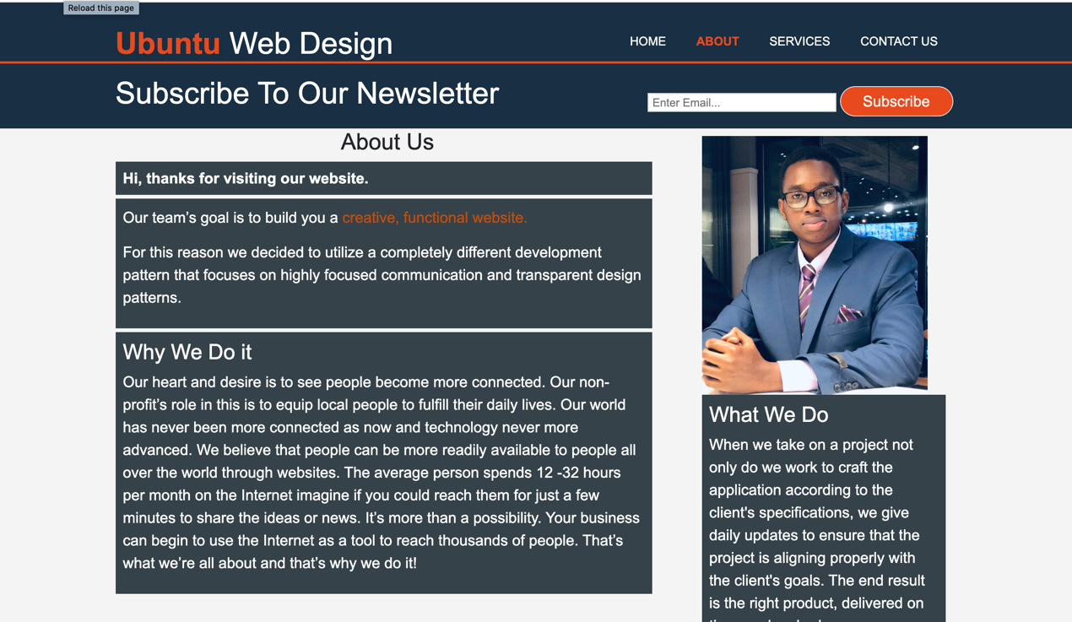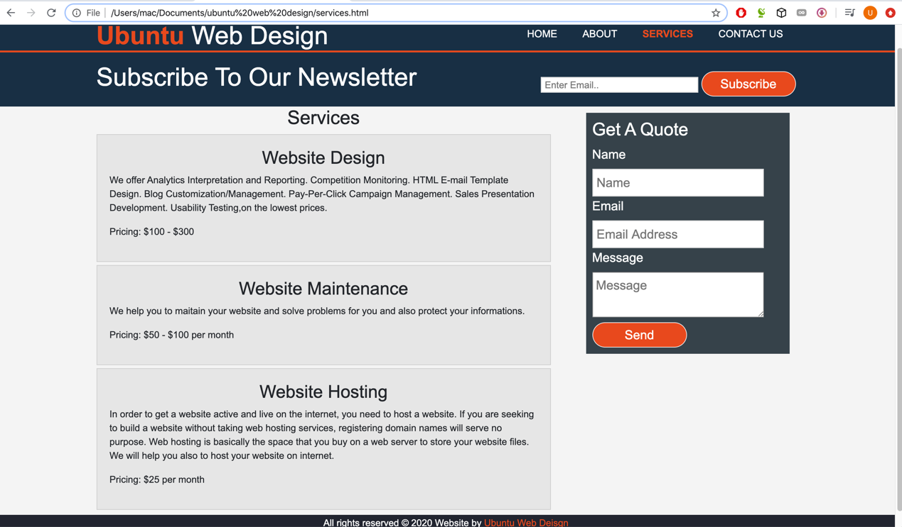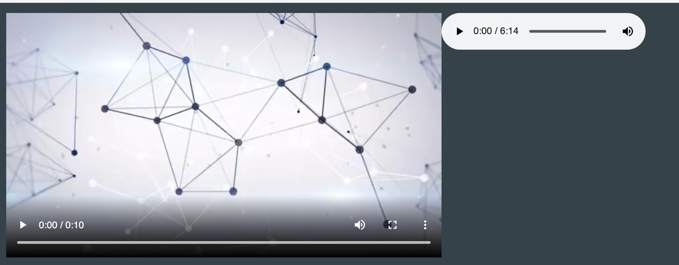

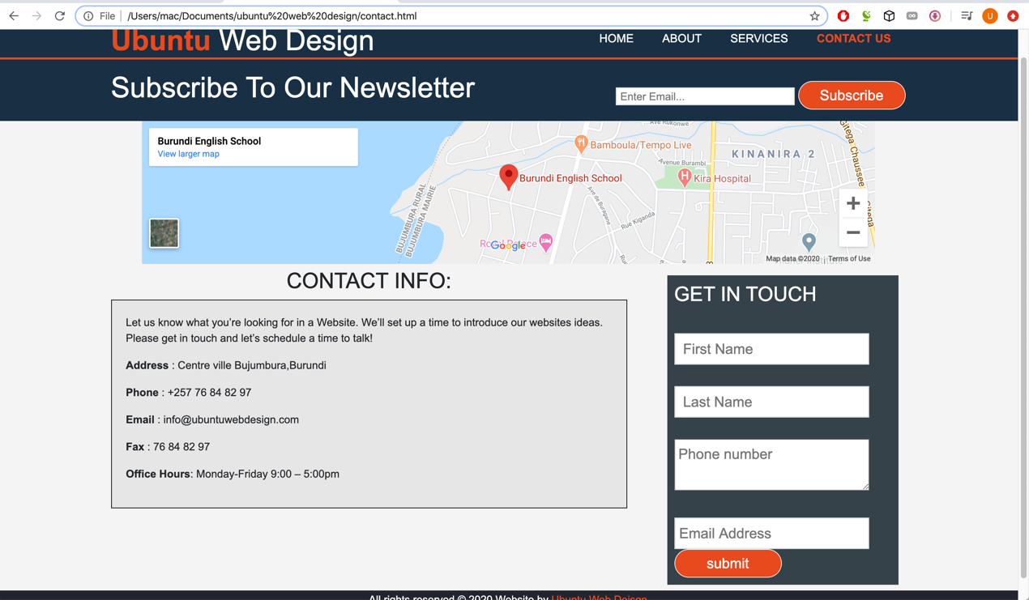

**4 Conclusion**

**I conclude by saying that every business needs a website** because now days each and everyone want to complete their tasks from their home.

So, we must be able to provide facilities to the peoples at their doorstep.

If you haven’t created a website for your business and you want to outsource your website design? Ubuntu web design offers professiona and affordable website design and digital marketing services to help get your business online and grow your business.